Problem: Windows Cryptographic Service Provider reported an error while using ePass2003 e-token

Details: While using e-token for signing PDF files in MCA/ROC, the following error is sometimes (Adobe Reader version 11 and above) reported.
Error encountered while signing:
The Windows Cryptographic Service Provider reported an error:
An internal error occurred.
Error Code: 2148073504
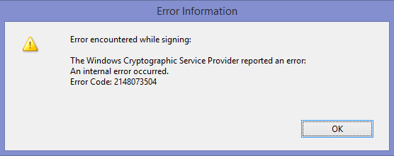

Solution:Solution:
Uninstall the ePass2003 driver. A system reboot might be required. Re-install the driver. Select Windows CSP when it prompts for 'Choose a CSP'. If prompted by Windows Security whether to install this device software, Click on Install as shown below.
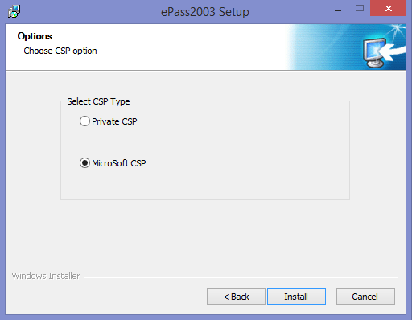
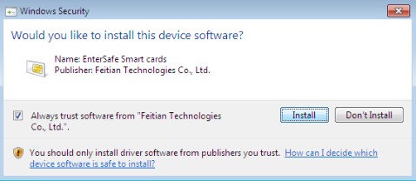
Complete the installation. Now you can sign PDF as usual using Adobe Reader in MCA website.

